1-2-3-4 Puzzle Name _______________________
Date _____________ Per _______

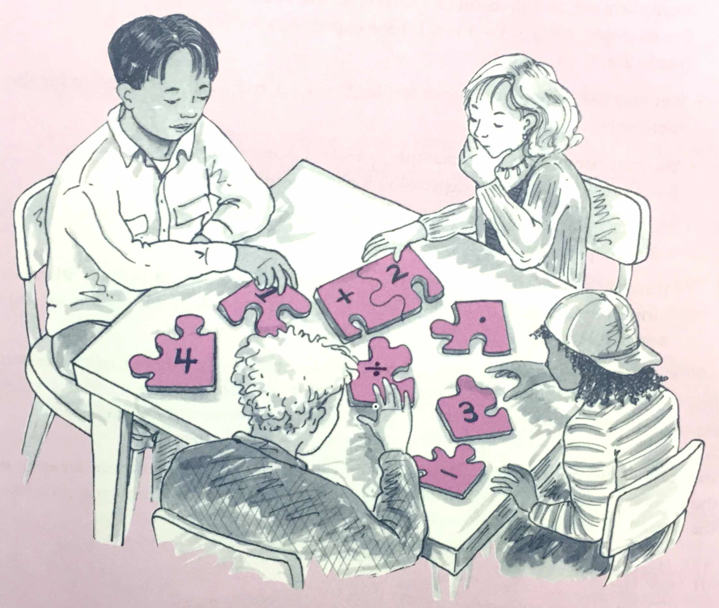
This problem is about using the digits 1, 2, 3, and 4, in any order you choose, to create arithmetic expressions that have different numerical answers when the rules for the order of operations (PEMDAS) are correctly used.

For this problem, a 1-2-3-4 expression is any expression written using each of these digits exactly once, according to the following rules.

- You may use any of the four basic arithmetic operations – addition, subtraction, multiplication, and division
- You may use exponents
- You may use factorials. A factorial is written with an exclamation point. For example, 4-factorial is written 4! and means 4321, which is 24.
- You may juxtapose two or more digits (that is, put them next to each other) to form a number such as 12, or 21, or 42, etc.
- You may use parentheses and brackets to change the meaning of an expression.
Your task in this problem is to create as many 1-2-3-4 expressions as you can for each of the numbers from 1 to 25. Remember: In every case, the expression must use each of the digits 1, 2, 3, and 4 exactly once.

